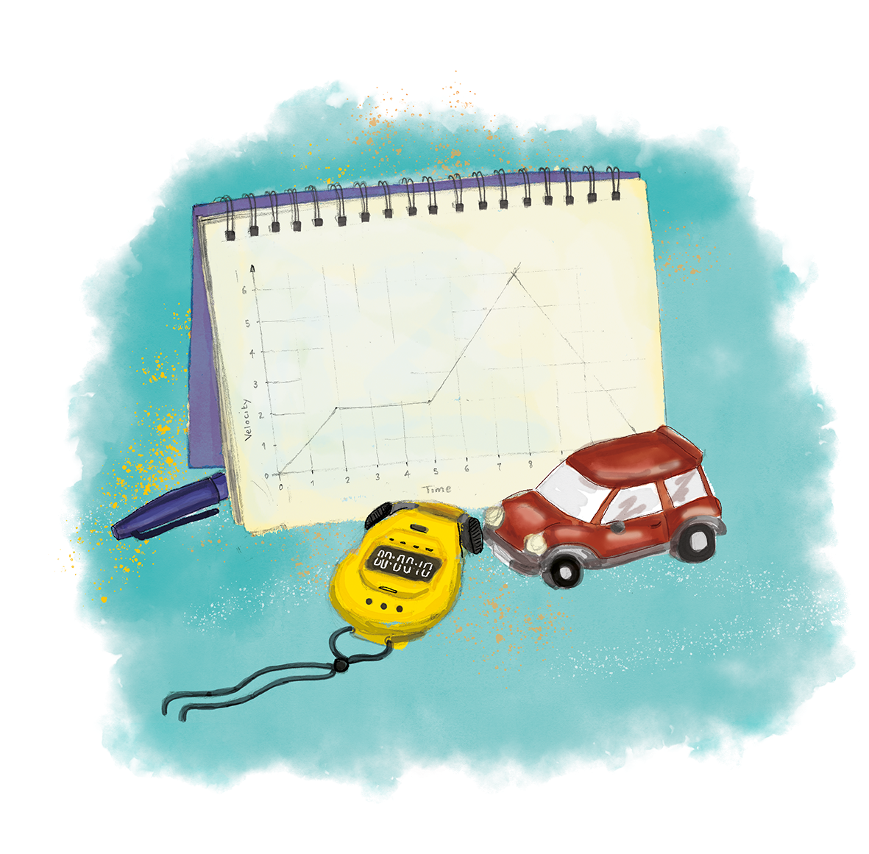


Big Idea: Forces predict motion
What will I be
learning about?

What does this mean?
Forces are pushes, pulls or twist which change an objects shape, speed or direction. There are many different types of force, including contact and non-contact forces which affect the shape and motion of objects in different ways. These ideas can be applied to many real-life situations, including calculating speed limits for cars based on stopping distances and balancing weights during construction.
What is this unit about?
In this unit you will be learning about how to calculate speed and relative motion. You will also learn about changing speed and acceleration, as well as learning to draw and interpret distance-time graphs. You will learn about pressure, including how to calculate pressure and different applications of pressure.
What should I already know?

Contact forces act directly on objects.
Non-contact forces act over a distance.
Balanced forces are equal and opposite.
Unbalanced forces cause an object to change shape, speed or direction.
Resultant force is the overall effect of all the forces acting on an object.
Force is measured in Newtons.
Free-body force diagrams can be used to represent the forces acting on an object.
Mass is the amount of matter in an object.
Weight is the effect of gravity on the mass.
Friction acts in the opposite direction to motion.
Speed can be calculated using distance divided by time.
Journeys can be represented using distance-time graphs.
A horizontal line on a distance-time graph represents a stationary object.
The slope (gradient) of a distance-time graph represents the speed of an object.
Acceleration

Why does a space rocket need so much force to lift off? Can humans keep getting faster at the 100 m sprint? What would happen if you jumped through a hole through the centre of the Earth?
The ways in which objects move depends on the forces acting on them. If the forces acting on an object are unbalanced, the object will change its speed, direction or shape. The behaviour of objects in motion follow mathematical laws that can be used to make predictions about speed, distance travelled, the time taken and acceleration.
This is the third unit we are studying as part of the big idea: Forces Predict Motion
In this unit we will learn the effect of forces on the motion of objects, learning about Isaac Newton’s First Law. We will also review the effects of balanced and unbalanced forces. We will also look at Newton’s Third Law and learn how to describe forces in terms of action- reaction pairs. We will learn about the differences between scalar and vector quantities and examples of each, comparing speed and velocity; distance and displacement. By the end of this unit we will be able to describe the forces acting on an object based on its motion.
We will develop lots of maths skills in this unit and learn how to do some complex calculations to find the resultant force of an object using a graph. We will also learn how to calculate acceleration. By the end of this unit we will be able to describe motion using velocity-time graphs and interpret these qualitatively and quantitatively.
We will develop our practical enquiry skills in this unit by doing an investigation into acceleration, measuring for ourselves the acceleration of a small object.
TASKS:
What subject will this unit focus on? (circle the correct subject)
BIOLOGY CHEMISTRY PHYSICS

There are lots of keywords underlined above. List these into the two columns:
Words I know | Words I haven’t seen before
To answer before the unit:
- What are you most excited to learn about in this topic?
________________________________________________________________________
________________________________________________________________________
________________________________________________________________________
- What do you already know about this topic?
________________________________________________________________________
________________________________________________________________________
________________________________________________________________________
________________________________________________________________________
- Why do you think it’s important to learn about how forces predict motion?
________________________________________________________________________
________________________________________________________________________
________________________________________________________________________
________________________________________________________________________
- What knowledge from previous science lessons might help us?
________________________________________________________________________
________________________________________________________________________
________________________________________________________________________
________________________________________________________________________
- What questions do you have about this topic?
________________________________________________________________________
________________________________________________________________________
________________________________________________________________________
________________________________________________________________________
To answer at the end of the unit:
- Tick off any words in the ‘words I haven’t seen before’ column that you are now confident with. Circle any you still need more practice to use.
- What have you most enjoyed about this unit?
________________________________________________________________________
________________________________________________________________________
________________________________________________________________________
________________________________________________________________________
- What more would you like to learn about forces as part of the big idea: ‘forces predict motion’?
________________________________________________________________________
________________________________________________________________________
________________________________________________________________________
This multiple choice assessment will check that you are ready to start learning about this unit. Take this quiz without any help.
Pre-Test

When you’ve finished, check the answers on the next page and complete any ‘fix-it’ tasks before moving on to learn the new topic.
1. Which is the best definition for resultant force?
A. Equal forces acting in opposite directions
B. The overall effect of all the forces acting on an object
C. The biggest force acting on an object

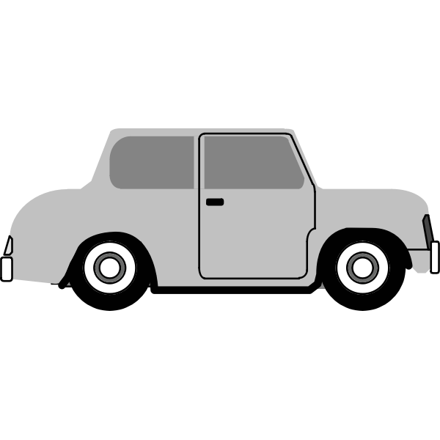
The diagram below shows some of the forces acting on a car. Use this diagram to answer Questions 2 to 4.
2000 N
800 N
2. What is the size of the resultant force on this car?
A. 1200 N left
B. 1200 N right
C. 2800 N

3. Which option best describes the motion of the car?
A. The car would be stationary
B. The car would be moving at a constant speed towards the right
C. The car would be accelerating towards the right

4. The backward force increases until it is also 2000 N. Which option best describes the new motion of the car?
A. The car would be moving at a constant speed towards the right
B. The car would slow down
C. The car would have stopped
5. Which option correctly shows how you would calculate the speed of a car (in SI units) that travelled 1 km in 1 minute?
- Speed = 1 km
1 minute
- Speed = 1000 m
60 seconds
- Speed = 1000 m x 60 seconds
Use the following distance-time graph to answer Questions 6 to 9.

6. When is the object not moving?
A. Between 0 and 5 seconds
B. Between 5 and 10 seconds
C. Between 15 and 30 seconds

7. When is the object moving fastest?
A. Between 5 and 10 seconds
B. Between 10 and 15 seconds
C. Between 15 and 30 seconds

8. What is the total distance travelled by this object?
A. 40 m
B. 35 m
C. 130 m

9. Which is the correct SI unit for speed?
A. m/s
B. mph
C. km/h

10. A runner runs 1500 m in 500 seconds before resting for 50 seconds. Then she runs another 500 m in 250 seconds. What is her average speed for the whole run?
A. 3 m/s
B. 2.5 m/s
C. 2.67 m/s
End of Unit Pre-Test. Turn over to see the answers. Give yourself a mark out of 10.
Pre-Test Answers

Question | Answer | What to do next (Fix-It task)
1 | B | If you answered A or C you need to review the definition of resultant force. Draw free body force diagrams to show a zero resultant force and a non-zero resultant force.
2 | B | If you answered A or C you need to review how to calculate resultant force. Calculate the resultant force on an object that has 50 N of force pushing it to the left and 75 N of force pushing it to the right.
3 | C | If you answered A or B you need to review the effects of unbalanced forces. State the three effects of unbalanced forces and explain how you can tell if forces are unbalanced.
4 | A | If you answered B or C you need to review the difference between balanced and unbalanced forces. Explain what is meant by each of these terms and describe the effects of each.
5 | B | If you answered A or C you need to review how to calculate speed and the SI units involved in the equation. State the equation used to calculate speed and the SI unit for speed, distance and time.
6 | A | If you answered B or C you need to review the meaning of a horizontal line on a distance-time graph. State what a horizontal line represents on a distance-time graph and explain how you could verify this.
7 | A | If you answered B or C you need to review the difference between a horizontal line and a positive gradient. Describe what each looks like and explain what they mean on a distance-time graph.
8 | B | If you answered A or C you need to review the features of a distance-time graph. Draw a distance-time graph of a runner that sprints 100 m in 10 seconds and then rests for 20 seconds.
9 | A | If you answered B or C you need to review the SI unit for speed. State the equation that links speed, distance and time and the SI unit for each.
10 | B | If you answered A or C you need to review how to calculate the average speed of an object over a journey. State the equation used to calculate average speed and use it to show the working to calculate average speed for this question.
Great job! Now you’re ready to start learning about acceleration!

Scalars and Vectors
Knowledge
Organiser

- Scalars are quantities which only have size (magnitude), such as distance, speed, mass and energy.
- Vectors are quantities with size and direction, such as displacement, velocity, acceleration, force and weight.
- Resultant force is a vector quantity
- Forces acting in the same direction can be added together
- Forces acting in opposite directions can be subtracted
- Resultant forces can be resolved into their horizontal and vertical components
Newton's Laws
- Newton’s Third Law states that every action has an equal and opposite reaction
- Newton’s First Law states than an object’s motion will not change unless acted upon by an unbalanced force
- If the resultant force is 0 N a stationary object will remain stationary
- If the resultant force is 0 N an object in motion will continue moving at the same velocity
- If the resultant force is not 0 N a stationary object will accelerate in the direction of the resultant force
- If the resultant force is not 0 N an object in motion will accelerate in the direction of the resultant force
Acceleration
- Acceleration is the rate of change of velocity
- Acceleration happens when there is change in velocity (speeding up, slowing down or a change in direction)
- Negative acceleration (slowing down) can be called deceleration
- The Sl unit for acceleration is m/s²
- An object moving in a circle is accelerating because it is constantly changing direction
- Objects near Earth’s surface experience gravitational acceleration of
9.8 m/s²
- Air resistance/drag increases with speed
Velocity-Time Graphs
- Velocity-time graphs can be used to describe motion
- A horizontal line shows a constant velocity
- A straight line with a positive gradient (slope) shows that an object has a positive acceleration (speeding up)
- A straight line with a negative gradient (slope) shows that an object has a negative acceleration/deceleration (slowing down)
- Acceleration can be calculated by calculating the gradient
- Distance can be calculated from the area under the graph
- A curved line shows that acceleration is changing

Acceleration The rate of change of velocity.
Glossary
Acceleration is how quickly an object changes speed or direction.
Action A description of a change in a physical system.
Newton’s Third Law describes how every action has an equal and opposite reaction.
Area A two-dimensional quantity representing the amount of surface.
Area is measured in cm² or m².
Balanced Equal in size and opposite in direction.
When the forces acting on an object are balanced, the motion of the object does not change (if it was stationary, it will remain stationary and if it was moving it will continue to move at a steady speed in the same direction).
Component The horizontal or vertical part that makes up a diagonal vector.
An object being pulled along the ground has a horizontal and vertical component to the force.
Constant Velocity When an object travels at the same speed in the same direction.
The person walked with a constant velocity of 2 m/s East.
Contact Force Is a force that acts when objects are physically touching each other.
Friction and air resistance are contact forces.
Curve A continuous and smooth flowing line without any sharp turns.
A curve on a velocity-time graph shows that an object has a changing acceleration.
Deceleration Slowing down, also known as negative acceleration.
Deceleration involves a decrease in velocity.
Distance The length of a path or length between two points.
The distance a person walks is 2 m.
Displacement The change in position of an object.
The person’s displacement was 3 m North of their original position.
Final velocity A vector quantity that describes the speed and direction of an object after an acceleration.
If you drop a ball from a height, the velocity just before it hits the ground is the final velocity.
Force A force is a push, pull or twist that can change the shape, speed or direction of an object.
Weight and tension are examples of forces.
Friction A contact force acting between two surfaces that are moving across or trying to move across each other.
Friction acts in the opposite direction to motion.
Gradient The slope of a graph.
The steeper the gradient of velocity-time graph, the greater the acceleration.
Gravity The force of attraction that exists between any two objects with mass.
Gravity is the force that attracts objects to the Earth.
Initial Velocity A vector quantity that describes the velocity of an object before an acceleration.
If an object starts from rest then the initial velocity of the object is 0 m/s.
Mass Mass is a measurement of how much matter is in an object.
Mass is measured in kilograms (kg).
Non-contact Force A force which acts on an object over a distance.
Gravity is an example of a non-contact force.
Resultant The sum of two or more vectors: the result of adding two or more vectors together.
The resultant displacement is calculated from vectors.
Scalar Quantities that have magnitude (size) only.
Speed is an example of a scalar.
Slope A measure of the steepness of a line.
Slopes can be seen in velocity-time graphs.
Speed The distance covered per unit time.
An object that covers 10 metres in 10 seconds has a speed of 1 m/s.
Stationary Not moving.
A stationary object has a speed of 0 m/s.
Tangent A straight line touching a curve at a single point without crossing the line.
The acceleration can be found by calculating the gradient of a tangent to a curve.
Unbalanced Forces that are not equal and opposite, a non-zero resultant force.
An unbalanced force can change the shape, speed or direction of an object.
Vector Quantities that have both magnitude (size) and direction.
Force is an example of a vector quantity, e.g. 5 N left.
Velocity The speed of an object in a given direction.
An object has a velocity of 10 m/s to the left.
Vertical Perpendicular to an x-axis (an up or down line)
Height is a vertical measurement.
Weight The force that acts on a mass due to gravity.
Weight is measured in Newtons.

Do Now:
New Learning
Prior Knowledge Review

- State the definition of a force.
________________________________________________________________________
- What is the SI unit for force?
________________________________________________________________________
- Explain the difference between contact and non-contact forces.
________________________________________________________________________
- Explain the difference between balanced and unbalanced forces.
________________________________________________________________________
- State the definition of speed.
________________________________________________________________________

Foundation: State two examples of forces.
________________________________________________________________________

Stretch: Explain the difference between mass and weight and give the SI units for each.
________________________________________________________________________
________________________________________________________________________

Activities
and Practice
- State the definition of:
- A force
____________________________________________________________________
____________________________________________________________________
- Balanced forces
____________________________________________________________________
____________________________________________________________________
- Resultant force
____________________________________________________________________
____________________________________________________________________
- Contact force
____________________________________________________________________
____________________________________________________________________
- Non-contact force
____________________________________________________________________
____________________________________________________________________
- Friction
____________________________________________________________________
____________________________________________________________________
- Mass
____________________________________________________________________
____________________________________________________________________
- Weight
____________________________________________________________________
____________________________________________________________________
- State whether the following pairs of forces are balanced or unbalanced and calculate the resultant force in each case:
15 N
5 N
35 N
100 N
5 N
5 N
35 N
20 N

- Objects have different weights in different parts of the solar system.
- State the equation used to calculate weight.

- Complete the following table to show the masses and weights of objects in different parts of the solar system:

Take the gravitational field strength of the Moon as 1.6 N/kg
Mass | Weight on Earth | Weight on the Moon
50 kg
 | 800 N
 |  | 48 N

- State the definition of speed.
_____________________________________________________________________
_____________________________________________________________________
- State the equation used to calculate speed with the SI units for each quantity.

- Calculate the speed of a person who runs a 200 m race in 25 seconds.

- Calculate how long it takes a car to drive 1000 m at 20 m/s.

- Calculate how far a cyclist can travel in 1 minute at 15 m/s.

- Calculate how fast an aeroplane is travelling if it covers 3 km in
12 seconds.

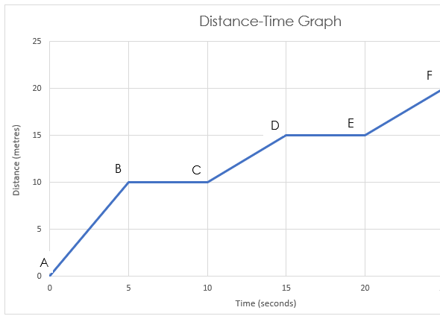
- Use the following distance-time graph to answer the questions below.

- Between which points in the graph is the object stationary?

- Between which points in the graph does the object have the greatest speed?

- Describe the motion during each stage of this journey
    - A-B

    - B-C

    - C-D

    - D-E

    - E-F

1. Which is the best definition of resultant force?
Exit Ticket
A. When the forces acting on an object cancel each other out
B. An interaction between two objects
C. The net force acting on an object

2. The speed of a car that travels 100 metres in 5 seconds is…
A. 20 m/s
B. 0.05 m/s
C. 500 m/s

3. A horizontal line on a distance-time graph represents…
A. An object moving at constant speed
B. An object accelerating
C. A stationary object
For question 2, read the guidance below and carry out the ‘fix-it’ task which has been set for you.
If you answered A
Speed is a measure of how far an object travels in a given time and can be calculated using speed = distance/time. In this case, the speed of the car would be 100 metres divided by 5 seconds, giving the car a speed of 20 m/s.
Calculate the speed of an aeroplane that covers 400 km in an hour.
If you answered B
Speed is a measure of how far an object travels in a given time and can be calculated using speed = distance/time. In this case, the speed of the car would be 100 metres divided by 5 seconds, giving the car a speed of 20 m/s.
Calculate the speed of a person who walks 200 m in 100 seconds.
If you answered C
Speed is a measure of how far an object travels in a given time and can be calculated using speed = distance/time. In this case, the speed of the car would be 100 metres divided by 5 seconds, giving the car a speed of 20 m/s.
Calculate the speed of a baby crawling 5 metres in 10 seconds.
Do Now:
New Learning
Scalars and Vectors

- State the definition of speed.
________________________________________________________________________
- State the equation used to calculate speed.
________________________________________________________________________
- State the SI unit for speed.
________________________________________________________________________
- State the SI units for mass and weight.
________________________________________________________________________
- Explain the difference between mass and weight.
________________________________________________________________________

Foundation: What are the SI units for distance and time?
________________________________________________________________________

Stretch: Calculate the speed of a runner who covers 5 km in 30 minutes.
________________________________________________________________________
________________________________________________________________________
A scalar is a quantity that only has size, such as distance, speed, mass and energy. A vector is a quantity that has size and direction, such as displacement, velocity, acceleration, force and weight.

Speed is how far an object travels in a given time and is calculated using the equation:
Speed = Distance
Time

Distance is how far an object travels. The SI unit for distance is metres (m), the SI unit for time is seconds (s) and the SI unit for speed is metres per second (m/s).
Velocity is how fast an object travels in a given direction, for example 5 m/s North.
Velocity is calculated using the equation:
Velocity = Displacement
Time

Displacement is how far an object is from its original position or from a given point of reference.

Examples:
      - A person walks 100 m North and then 100 m South. This means
they will return to their original position. The distance they have
travelled is how far they have travelled, which is 200 m. Their
displacement is 0 m because they are in the same place as their
starting position. They completed this walk in 200 seconds.
100 m
100 m
Velocity = Displacement
Time
Velocity = 0 m
200 s
Velocity = 0 m/s
Speed = Distance
Time
Speed = 200 m
200 s
Speed = 1 m/s

      - Another person walks 100 m North and then 50 m South. The distance
they have travelled is 150 m but now their displacement is 50 m
North, as this is where they are relative to their starting point. They
completed this walk in 150 seconds.
100 m
50 m
Velocity = Displacement
Time
Velocity = 50 m North
150 s
Velocity = 0.33 m/s North

Speed = Distance
Time
Speed = 150 m
150 s
Speed = 1 m/s

Note: in both of these cases we have calculated average velocity, which uses the total distance and the total time. In some cases you may be asked to calculate the velocity for a specific part of the journey rather than the average of the whole journey.
Activities
and Practice
- State the definition of a scalar quantity.
________________________________________________________________________
- State the definition of a vector.
________________________________________________________________________
- Sort the following quantities into scalars and vectors:
Displacement, acceleration, distance, speed, mass, weight, energy, force, velocity
Scalar | Vector

- State the definitions of:
  - Distance
____________________________________________________________________
  - Displacement
____________________________________________________________________
  - Speed
____________________________________________________________________
  - Velocity
____________________________________________________________________

- Soldiers go on a march in the desert. They first walk 6km west from their camp, rest for a bit then 10km east, rest a bit then 4km west. Calculate:
        - The distance covered

        - The total displacement

        - Their displacement at the second rest stop

- Harry walks 10 km South. Then walks 6 km North. Calculate:
- The distance travelled

- His total displacement

- A cyclist cycles 800m in a straight line North, turns around and completes a further 1400 m South. The cyclist completes the whole route in 200s.
              - Calculate the distance covered

              - Calculate the displacement of the cyclist

              - Calculate the average speed

              - Calculate the average velocity

- A trolley is pushed 10 m to the right, then 5 m to the left and back 7 m towards the right. The total time taken was 2 minutes.
- Calculate the total distance covered.

- Calculate the displacement.

- Calculate the average speed.

- Calculate the average velocity.

1. Velocity is a vector quantity because…
Exit Ticket

A. It has size and direction
B. It has size only
C. It is how much distance is covered in a given time
2. If a person walks 4 m left then 8 m right…
A. Their displacement is 12 m right
B. Their displacement is 4 m right
C. Their displacement is 4 m left
3. What would the velocity of the person in Q2 be if they completed these movements in 8 seconds?
A. 1.5 m/s right
B. 0.5 m/s
C. 0.5 m/s right
For question 3, read the guidance below and carry out the ‘fix-it’ task which has been set for you.
If you answered A
Velocity is a vector quantity and a measure of how fast an object travels in a particular direction, calculated using displacement divided by time. In this case the displacement is 4 m right and the time taken was 8 seconds, giving the person a velocity of 0.5 m/s right.
Explain the difference between speed and velocity and calculate the speed of the person in Q2 if they completed the movements in 8 seconds.

If you answered B
Velocity is a vector quantity and a measure of how fast an object travels in a particular direction, calculated using displacement divided by time. In this case the displacement is 4 m right and the time taken was 8 seconds, giving the person a velocity of 0.5 m/s right.
Explain the difference between speed and velocity and the difference between distance and displacement.

If you answered C
Velocity is a vector quantity and a measure of how fast an object travels in a particular direction, calculated using displacement divided by time. In this case the displacement is 4 m right and the time taken was 8 seconds, giving the person a velocity of 0.5 m/s right.
Calculate the speed of the person in Q2 and explain how this is different to their velocity.
Do Now:
New Learning
Resultant Vectors
- State the definition of a scalar quantity.
________________________________________________________________________
- State the definition of a vector quantity.
________________________________________________________________________
- Classify force as a scalar or a vector quantity.
________________________________________________________________________
- State the definition of resultant force.
________________________________________________________________________
- Sketch two lines that are perpendicular to each other.
________________________________________________________________________

Foundation: 2 boys both push a trolley to the left with a force of 80 N each. What is the resultant force?
________________________________________________________________________

Stretch: Explain the difference between speed and velocity and how you would calculate both.
________________________________________________________________________
________________________________________________________________________
A resultant vector is the combination of two (or more) single vectors.
E.g. Resultant force
Other vectors can combined to calculate a resultant, including displacement and velocity.
5 N
20 N

Vectors acting in the same direction can be added together.
Vectors acting in the opposite direction can be subtracted.
Resultant force = 15 N left
5 N
20 N
350 m

200 m

Resultant displacement = 150 m right
2 m/s
6 m/s
Resultant velocity = 8 m/s left

When vectors act at right angles to each other, scale drawings can be used to calculate the resultant vector.
Example:
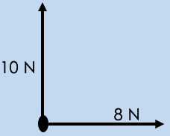

These vectors cannot be added together or subtracted because they are not acting in opposite directions or the same direction. We know that the resultant vector will be in the middle of these vectors but to determine a value we need to use a vector diagram, which is a scale drawing of the vectors.
Method:
- Choose a suitable scale to use for the scale drawing.
In this example we have two vectors, 8 N and 10 N,
so we can use a scale of 1 N represents 1 cm. We
could use 2 N = 1 cm, but this could make our
drawing much smaller.
1 N = 1 cm

- Draw the first vector using your scale in pencil,
using a ruler. In this case 8 N will be represented by
a line of 8 cm. Make sure that the whole arrow is in
this 8 cm line - it should not be an 8 cm line with an
arrow then added on the end as this would not
represent the correct value.
8 N = 8 cm
10 N = 10 cm
- Draw the second vector from the same point of
origin, using the same scale and also using a ruler
and pencil. It should be perpendicular (at right
angles) to the first vector. In this case that would be
a 10 cm line going upward from the 8 cm line.

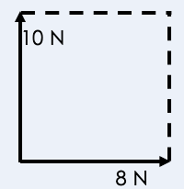

- Draw a dotted line parallel to each of the vectors to make a rectangle

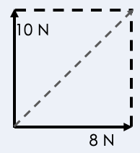
- Draw another dotted line from the point of origin to the opposite corner - this is your resultant vector.

- Measure the length of this resultant and use your scale to determine its real magnitude. In this case the line of the resultant was 12.8 cm, meaning that the actual size of the resultant would be 12.8 N.

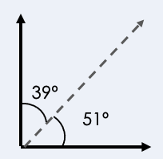
- Nearly done! Because we are looking at resultant vectors, our answer can only be fully described with a direction too. Our direction is an angle, so we measure the angle between the first vector and the resultant using a protractor. This gives us the direction that the resultant is acting in, in this case 51º from the horizontal line so we can describe it as 51º from horizontal. If we measured from the vertical vector our angle would be 39º and we could describe it as 39º from vertical. Both are correct options.

- Finally we can write our answer out in full. The resultant vector (in this case force) is 12.8 N at 51º from horizontal (or 39º from vertical).

- The direction can also be written as a bearing but an angle is also fine. This would be on a bearing of 039º.
As we are looking at resultant vectors, the final answer must be stated with a direction. This is where the angle between the resultant vector and the first drawn vector is used. Depending on which vector you have drawn first, the angle will be different. Both options are equally correct and will add up to 90°.

Scale Drawings
Activities
and Practice
For each set of vectors choose a suitable scale and ensure lengths and angles are measured carefully and accurately. Ensure you a vector diagram for each drawing and state a magnitude and direction of your resultant vector.
- 5 km East then 15 km South.

- An object has a weight of 500 N and is pulled to the left with a force of
300 N and to the right with a force of 200 N.

- 15 m East and 25 m North.

- 100 N right and 80 N down.

- 100 km South and 60 km East.

- 12 N up, 6 N right, 3 N down and 9 N left.

- 100 m South, 50 m West and 30 m North.

1. Which is the best definition of resultant vector?
Exit Ticket
A. A vector that has the same effect as two or more single vectors.
B. The net force acting on an object.
C. A quantity that has both size and direction.

2. A diagonal vector of magnitude 12 N could be made up of…
A. Two horizontal 6 N components
B. A horizontal 18 N and a horizontal 6 N component
C. Two 8.5 N components

3. Which is an essential aspect to include in a scale drawing?
A. Lines drawn in pen
B. A scale
C. A bearing
For question 2, read the guidance below and carry out the ‘fix-it’ task which has been set for you.
If you answered A
Vectors acting at right angles (perpendicular) to each other can be resolved into a resultant vector using a scale drawing of a vector diagram. Two horizontal 6 N components could make a vector of 12 N but it would not be acting diagonally.
Describe how to calculate a resultant vector when vectors are acting a) in the same direction, b) in opposite directions, and c) at right angles to each other.

If you answered B
Vectors acting at right angles (perpendicular) to each other can be resolved into a resultant vector using a scale drawing of a vector diagram. Two horizontal components could make a vector of 12 N but it would not be acting diagonally.
Describe how to calculate a resultant vector when vectors are acting a) in the same direction, b) in opposite directions, and c) at right angles to each other.

If you answered C
Vectors acting at right angles (perpendicular) to each other can be resolved into a resultant vector using a scale drawing of a vector diagram. Two 8.5 N vectors could be acting at right angles to each other to produce a diagonal vector of magnitude 12 N.
Describe how two single vectors could combine to make a) the largest possible resultant, and b) the smallest possible resultant.
Do Now:
New Learning
Resolving Vectors

- State the definition of a resultant vector.
________________________________________________________________________
- State the definition of resultant force.
________________________________________________________________________
- Describe how to calculate a resultant force when two forces are acting in the same direction.
________________________________________________________________________
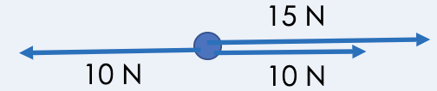
- Calculate the resultant force shown by this free-body diagram.
________________________________________________________________________
- An object is moving at a steady speed. What can be said about the forces acting upon it?
________________________________________________________________________

Foundation: State the resultant force on a stationary object.
________________________________________________________________________

Stretch: Explain why it is incorrect to say that if balanced forces are acting on an object it must be stationary.
________________________________________________________________________
________________________________________________________________________

We have already looked at how we can determine the resultant of two perpendicular vectors, but we can also find the resultant of any two vectors (that do not have to be perpendicular) by using a scale drawing. Consider these two forces, acting with an angle of 30º between them.
45 N
30 N
30º

This time instead of using a rectangle to complete our vector diagram, we are going to use a parallelogram, so this method is sometimes called ‘the parallelogram method’.
- In the same way that we choose a suitable scale for perpendicular vectors, we do the same here. A suitable scale here may be 1 cm = 5 N, but there are a few different options that could be chosen.
- Draw the first vector using the scale. We can start with 30 N, so will draw a line of 6 cm.
- Measure the angle between the vectors and mark this on your page.
- Draw the second vector using this measured angle and your chosen scale, in this case 45 N will mean a line of length 9 cm.
- Draw lines that are parallel to each of the vectors, thereby creating a parallelogram.
- Measure the length from the origin to the tip of the new parallelogram - this is the resultant. Use the scale to determine its real magnitude. In this case the length (blue arrow) is 14.7 cm so using the scale gives a resultant with magnitude 73.5 N.
- Use a protractor to measure the angle or bearing of the resultant. It is easiest to describe as $x$ of horizontal or $x$ of vertical so you may want to mark on a dotted horizontal or vertical line to measure from. In this case our 30 N force was 10º below horizontal so we can include this in our answer. The angle of this resultant vector is 28º below horizontal.
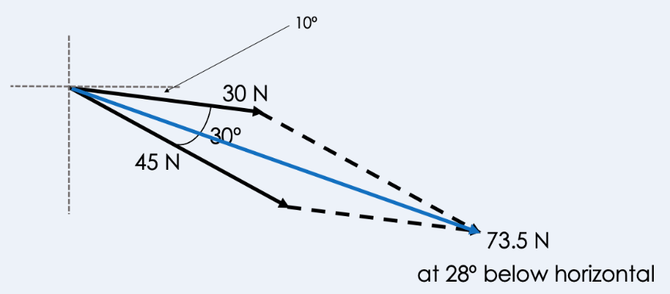
A good way to check that you have your magnitude correct is that if the two vectors were acting in the same direction they would have the maximum resultant, so your measured resultant can never be greater than this.
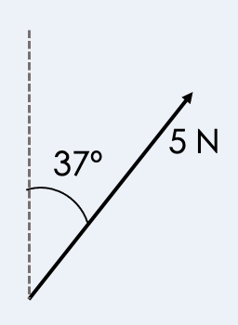
We know that two vectors can be combined into a resultant vector that has the same effect. But what happens when we have the resultant vector to start with? We are going to work backwards and determine the single vectors that our resultant vector must be made up of.
So what do we do? We can use the same steps but work backwards to determine our components!

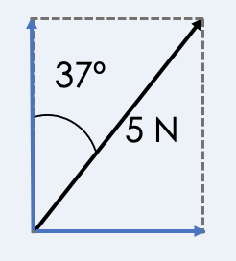
- Determine a suitable scale - exactly the same way that we chose a scale in the last lesson, we will do the same here. A sensible scale to use here could be 1 N = 1 cm.
- Measure the angle given using a protractor and mark this neatly on your page.
- Use your scale to draw the resultant with the correct magnitude (in this case 5 cm) at the angle that you marked out.
- Use a ruler to draw dotted lines to make a right-angled triangle on either side of the resultant, giving a full rectangle (it should look like the vector diagrams from last lesson)
- Measure the length of the horizontal and vertical components that come from the point of origin of the resultant.
- Use your scale to determine the actual magnitudes of these single vectors and describe them as the horizontal and vertical components.
Horizontal line = 3 cm so the horizontal component is 3 N right.
Vertical line = 4 cm so the vertical component is 4 N up.
Remember these are still single vectors and vectors need to have a direction so our answer should have the directions of the components too.
Sometimes you may be asked to draw a free-body force diagram to show where the forces are acting from. We can use this triangle method to determine our resultant but both forces would still act from the point of origin (the centre of mass) of the object, so we can draw them in our free-body force diagram as normal, using our triangle to remind us of the direction of their actions.

Activities
and Practice
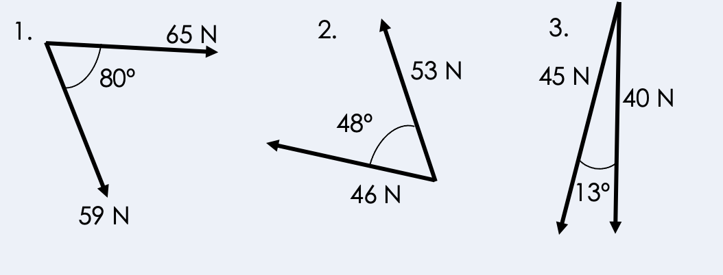
Use a scale drawing to determine the resultant vector from each of the following pairs:

Complete the following sentences:
- Resultant vectors acting at an angle can be resolved into _________ and ___________ components.
- All scale drawing should have a ____________ and be drawn using a ___________ and a __________.
- A ___________ should be used to measure angles.
- Components should be described with both _______________ and _____________.
Resolve each of the following resultant vectors into their horizontal and vertical components. You will have to redraw these diagrams as they are not to scale.
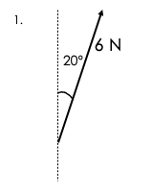
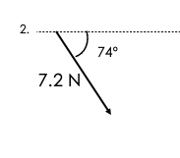

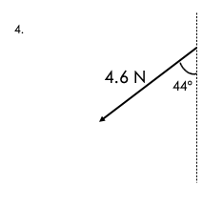
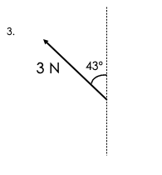

- Challenge: 8.6 km on a bearing of 232º.
1. What is the difference between scalars and vectors?
Exit Ticket
A. Scalars always have a direction
B. Vectors always have a direction
C. Vectors sometimes have a direction
10 N
2. Which are the most likely components of this resultant vector?
A. 20 N up and 15 N right
B. 8 N right and 6 N up
C. 5 N right and 15 N down

3. Which is most likely to be the result of these single vectors?
6 N
8 N
A. 18 N
B. 2 N
C. 13 N
For question 2, read the guidance below and carry out the ‘fix-it’ task which has been set for you.
If you answered A
We can work backwards from a diagonal vector to resolve it into horizontal and vertical components. In this case the direction is between up and right, meaning that our components will be acting upwards and to the right. A diagonal vector will be larger than the single vectors acting perpendicularly to produce it, so 20 N and 15 N acting perpendicular to each other could not produce a resultant vector of 10 N.
Describe how two single vectors could combine to make a) the largest possible resultant, and b) the smallest possible resultant.

If you answered B
We can work backwards from a diagonal vector to resolve it into horizontal and vertical components. In this case the direction is between up and right, meaning that our components will be acting upwards and to the right. A diagonal vector will be larger than the single vectors acting perpendicularly to produce it, so 8 N and 6 N acting perpendicular to each other could produce a resultant vector of 10 N.
Describe the process for resolving a diagonal vector into components.

If you answered C
We can work backwards from a diagonal vector to resolve it into horizontal and vertical components. In this case the direction is between up and right, meaning that our components will be acting upwards and to the right. Components acting right and downwards would produce a resultant in between these directions.
Describe the directions of the components that would produce a resultant that acted between down and left.
Do Now:
New Learning
Newton’s Third Law

- Explain the difference between scalar and vector quantities.
________________________________________________________________________
- Give an example of a scalar quantity.
________________________________________________________________________
- Give an example of a vector quantity.
________________________________________________________________________
- Describe how to calculate resultant force.
________________________________________________________________________
- State the SI units of force and the piece of equipment used to measure force.
________________________________________________________________________

Foundation: State the definition of resultant force.
________________________________________________________________________

Stretch: Describe how two vectors could be combined to produce a) a minimum resultant vector and b) a maximum resultant vector.
________________________________________________________________________
________________________________________________________________________
Newton’s Third Law states that every action has an equal and opposite reaction When two objects interact, they exert equal and opposite forces on each other.

This can also be worded as:
If Object A exerts a force on Object B, Object B will exert an equal and opposite force on Object A.
Note: The terms equal and opposite do not mean the forces are cancelling each other out. If the two equal and opposite forces were acting on the same object they would produce a resultant force of 0 N but the forces are not acting on the same object. The forces are acting on different objects.
For example:
These two skaters push against each other and would move off in opposite directions because they are exerting an equal and opposite force on each other. These forces are not both acting on the same object, but rather on different objects. These forces could be separated into two different free-body force diagrams to show which object each force is acting on.
Note: Even if the skaters were different sizes or masses, both would still experience the same force. If the skaters had the same mass, they would move off with equal acceleration. If they did not have the same mass, they would still experience the same force but the skater with the greater mass would accelerate more slowly. This idea will be covered again in Newton’s Second Law.
Newton’s Third Law also explains how objects are able to move.
e.g. A car is able to move because when the wheel exerts a force on the ground, the ground exerts an equal and opposite force on the wheel, pushing it forwards. Theoretically it means the ground would be pushed in the opposite direction but because the Earth is so big, we do not notice this. You will learn more about this idea when you study Newton’s Second Law.

Activities
and Practice
- State Newton’s Third Law.
________________________________________________________________________
________________________________________________________________________
________________________________________________________________________
- For each of the scenarios identify the action-reaction pairs.

- A rocket taking off

- A man swimming

- The moon orbiting the Earth

- A person leaning against a wall

- Explain why a gun recoils when a bullet is shot out of it.
________________________________________________________________________
________________________________________________________________________
________________________________________________________________________
- Describe what would happen if a person jumps off a boat and explain why this would happen.
________________________________________________________________________
________________________________________________________________________

1. Newton’s Third Law states that…
Exit Ticket
A. Objects will exert equal and opposite forces on each other that will cancel out
B. If an object exerts a force on another it will exert the same force
C. Every action has an equal and opposite reaction

2. The reaction force to the force exerted by a gun on a bullet is…
A. The weight of the gun
B. The force exerted by the bullet on the gun
C. The air resistance of the bullet

3. If a large person and a small person bump into each other, what can be said about the forces they exert on each other?
A. The large person will exert a larger force
B. The small person will exert a larger force
C. They will exert the same size of force on each other
For question 1, read the guidance below and carry out the ‘fix-it’ task which has been set for you.
If you answered A
Newton’s Third Law involves action-reaction pairs, which means that if Object A exerts a force on Object B, Object B will exert an equal and opposite force on Object A. These forces are equal and opposite but because they are each acting on the other object, they would not cancel each other out. They would be drawn as two separate free-body force diagrams.
Describe the action-reaction pair acting between the Earth and the Moon.

If you answered B
Newton’s Third Law involves action-reaction pairs, which means that if Object A exerts a force on Object B, Object B will exert an equal and opposite force on Object A. These forces cannot be described as the same force because although they have the same magnitude, they are acting in opposite directions.
Explain what is meant by an action-reaction pair.

If you answered C
Newton’s Third Law involves action-reaction pairs, which means that if Object A exerts a force on Object B, Object B will exert an equal and opposite force on Object A. This means that every action has an equal and opposite reaction.
Suggest why two people of different size bumping into each other will rebound at different speeds despite experiencing the same force.
Do Now:
New Learning
Newton’s First Law

- Define resultant force.
________________________________________________________________________
- State Newton’s Third Law.
________________________________________________________________________
- Explain the difference between speed and velocity.
________________________________________________________________________
- Name a force that acts in the opposite direction to motion.
________________________________________________________________________
- Describe the possible effects of an unbalanced force.
________________________________________________________________________

Foundation: State the SI unit of force.
________________________________________________________________________

Stretch: Explain how two diagonal forces could produce a resultant of 0 N.
________________________________________________________________________
________________________________________________________________________
Newton’s First Law states that an objects motion will not change unless acted upon by an unbalanced force.

The tendency of objects to continue in their state of motion is called inertia.
An unbalanced force is a non-zero resultant force.
If the resultant force is 0 N the forces are balanced and the object is in equilibrium.
If the resultant force is 0 N (the forces are balanced):
- A stationary object will stay stationary
- An object in motion will continue moving at the same velocity
If the resultant force is not 0 N (the forces are unbalanced):
- A stationary object will accelerate in the direction of the resultant force
- An object in motion will accelerate in the direction of the resultant force
Note: many people will assume that an object will always move in the direction of the resultant force. It is important to remember that it will accelerate in the direction of the resultant force as this takes into account the motion that the object already had. For example, if an object initially moving towards the right experienced a resultant force to the left, it would not suddenly start moving towards the left. Its acceleration would be towards the left, which means that it would continue moving to the right but be slowing down.

Activities
and Practice
- State Newton’s First Law.
________________________________________________________________________
________________________________________________________________________
________________________________________________________________________
- State the definition of:
- Inertia. _____________________________________________________________________
_____________________________________________________________________
_____________________________________________________________________
- Resultant force. _____________________________________________________________________
_____________________________________________________________________
_____________________________________________________________________
- Equilibrium _____________________________________________________________________
_____________________________________________________________________
_____________________________________________________________________

- Explain the difference between balanced and unbalanced forces.
________________________________________________________________________
________________________________________________________________________
________________________________________________________________________

- Complete the table for each scenario after calculating the resultant force in each case.

20 N
20 N

Resultant Force =
_____________________________________________________________________________

Initial motion | Resulting motion
Object was initially stationary
Object was initially moving at constant speed to the right
Object was initially moving at constant speed to the left

10 N
20 N

Resultant Force =
_____________________________________________________________________________

Initial motion | Resulting motion
Object was initially stationary
Object was initially moving at constant speed to the right
Object was initially moving at constant speed to the left

70 N
100 N
30 N

Resultant Force =
_____________________________________________________________________________

Initial motion | Resulting motion
Object was initially stationary
Object was initially moving at constant speed to the right
Object was initially moving at constant speed to the left
70 N
50 N

30 N

Resultant Force =
_____________________________________________________________________________

Initial motion | Resulting motion
Object was initially stationary
Object was initially moving at constant speed to the right
Object was initially moving at constant speed to the left

1. Newton’s First Law states that…
Exit Ticket

A. Objects’ motion will not change unless acted upon by an unbalanced force
B. Objects will remain stationary if they are acted upon by an unbalanced force
C. Every action has an equal and opposite reaction
2. An object that is moving 0.5 m/s to the right is acted upon by a resultant force of 5 N left. Which best describes the resulting motion?
A. It will move at 0.5 m/s to the left
B. It will now be stationary
C. It will slow down towards the right
3. Which of these resultant forces would cause a stationary object to accelerate to the left?
A. 0 N
B. 5 N left
For question 2, read the guidance below and carry out the ‘fix-it’ task which has been set for you.
C. 5 N right
If you answered A
Newton’s First Law states that an object’s motion will not change unless it is acted upon by an unbalanced force. In this case there is a resultant force so the object will accelerate in the direction of the resultant force. This does not mean it necessarily moves in the direction of the resultant force. This object was already moving to the right so the resulting motion would be that it continues moving in its original direction but will begin to slow down.
Describe the resulting motion of an object that was initially moving towards the left but was acted upon by an unbalanced resultant force towards the right.

If you answered B
Newton’s First Law states that an object’s motion will not change unless it is acted upon by an unbalanced force. In this case there is a resultant force so the object will accelerate in the direction of the resultant force. This does not mean it necessarily moves in the direction of the resultant force. This object was already moving to the right so the resulting motion would be that it continues moving in its original direction but will begin to slow down. It may eventually slow down to a stop but it would not instantly become stationary.
Explain the effects of an unbalanced force on a) a stationary object and b) an object already in motion.

If you answered C
Newton’s First Law states that an object’s motion will not change unless it is acted upon by an unbalanced force. In this case there is a resultant force so the object will accelerate in the direction of the resultant force. This does not mean it necessarily moves in the direction of the resultant force. This object was already moving to the right so the resulting motion would be that it continues moving in its original direction but will begin to slow down.
Explain the difference between an object moving in the direction of a resultant force and an object accelerating in the direction of a resultant force.

Do Now:
New Learning
Acceleration
- State Newton’s First Law.
________________________________________________________________________
- State Newton’s Third Law.
________________________________________________________________________
- Define velocity.
________________________________________________________________________
- Describe what happens to a stationary object if it is acted upon by an unbalanced force.
________________________________________________________________________
- Describe the possible motion of an object with balanced forces acting on it.
________________________________________________________________________

Foundation: State the SI unit for velocity.
________________________________________________________________________

Stretch: Explain the difference between speed and velocity and when you would use them.
______________________________________________________________________________
______________________________________________________________________________
Changing velocity could be an object speeding up, slowing down or changing direction. Acceleration is the rate of change in velocity, so it is a measure of how quickly the velocity is changing.

Acceleration is the rate of change of velocity.
a = Δ v
t

Δ v represents change in velocity, which is calculated using final velocity – initial velocity.
Example:
Calculate the acceleration of a car that goes from rest to 10 m/s in
5 seconds.
Acceleration = change in velocity
time
a = 10 m/s – 0 m/s
5 s
a = 2 m/s²
As acceleration is the rate of change of velocity its SI unit is m/s². A negative acceleration (an object slowing down) can be called deceleration. As acceleration is the rate of change of velocity, it is also a vector quantity.
Objects near the surface of the Earth experience acceleration due to gravity of 9.8 m/s². This is the same as the value that is used for gravitational field strength, because this is how quickly the speed of objects changes as they fall to Earth.
As objects speed up, air resistance increases. This is why cars and other objects have top speeds. As the car speeds up, the air resistance acting on it increases, until the car reaches a point where the thrust force becomes equal to the air resistance. The forces have balanced out and the resultant force is now 0 N, which means the car has reached a terminal velocity and travels at a constant velocity (speed in a particular direction).
- State the definition for acceleration and the SI unit for acceleration.
Activities
and Practice
________________________________________________________________________
________________________________________________________________________
________________________________________________________________________
- State the three different ways an objects velocity may change.
________________________________________________________________________
________________________________________________________________________
________________________________________________________________________
- State the equation used to calculate acceleration, with the units for each quantity.

- Calculate the acceleration of the following objects:
  - A car that goes from 0 to 30 m/s in 5 seconds

  - A runner that goes from 4m/s to 8 m/s in 10 seconds

  - A car travelling at 10 m/s that comes to a stop at traffic lights in
3 seconds

  - A dog walking at 3 m/s suddenly spotting a squirrel and starts chasing it at 12 m/s in 1.5 seconds

  - A train travelling at 50 m/s slows down to stop in 1 minute

- Explain what it means for an object to have a negative acceleration.
________________________________________________________________________
________________________________________________________________________
________________________________________________________________________
- Calculate the final velocity of:
  - A train that accelerates from rest at 10 m/s² for 8 seconds.

  - An eagle that accelerates from 6 m/s at 2 m/s² for 5 seconds.
- Calculate the initial velocity of:
  - an object that accelerates at 4 m/s² for 5 seconds and reaches a final velocity of 100 m/s.

  - an aeroplane that accelerates at 50 m/s² for 10 seconds and reaches a new velocity of 1000 m/s.
- Calculate how long it takes for:
  - A jet to reach 600 m/s if it started from rest and accelerated at 30 m/s².

  - A dog to reach 15 m/s from 5 m/s, accelerating at 2 m/s².
1. Acceleration is…
Exit Ticket
A. Rate of change of velocity
B. When an object gets faster
C. An increase in velocity

2. Which of these is an example of acceleration?
A. A car coming to a stop at traffic lights
B. A car driving over the speed limit at 20 m/s
C. Two trains passing each other at different speeds

3. What is the acceleration of a sprinter going from rest to 10 m/s in 2 seconds?
A. 5 m/s
B. 5 m/s²
C. -5 m/s²
For question 2, read the guidance below and carry out the ‘fix-it’ task which has been set for you.
If you answered A
Acceleration is the rate of change of velocity and can refer to an object speeding up, slowing down or changing direction. In this case, a car coming to a stop would be an example of acceleration as the velocity is changing. A negative acceleration or deceleration is still an example of acceleration.
Explain why acceleration is a vector quantity.

If you answered B
Acceleration is the rate of change of velocity and can refer to an object speeding up, slowing down or changing direction. A car driving over the speed limit at 20 m/s is still travelling at a constant speed, which means its velocity is not changing so this would not be an example of acceleration.
Describe the three different changes that would show acceleration and give an example of each.

If you answered C
Acceleration is the rate of change of velocity and can refer to an object speeding up, slowing down or changing direction. Two trains passing each other at different speeds would have relative motion to each other but there is not enough information in this scenario to confirm if the trains are accelerating. If a train was slowing down to stop at a station or getting faster leaving a station, these would be examples of acceleration.
Explain what is meant by constant velocity and explain why this is not an example of acceleration.
Do Now:
New Learning
Acceleration Investigation

- Define acceleration.
________________________________________________________________________
- State the SI unit for acceleration.
________________________________________________________________________
- State the equation used to calculate acceleration.
________________________________________________________________________
- Explain the difference between speed and velocity.
________________________________________________________________________
- Describe how to measure the speed of an object.
________________________________________________________________________

Foundation question: State the equation to calculate speed.
________________________________________________________________________

Stretch: Describe the information you would need to be able to measure the acceleration of an object.
________________________________________________________________________
________________________________________________________________________

Acceleration Investigation
Activities
and Practice
In this experiment you will measure the acceleration of a toy car and investigate how this changes when the force applied to it changes or the mass of the car changes.
Experiment 1
Measuring the effect of force on acceleration
Apparatus
- toy car/trolley
- metre ruler
- pencil/chalk/tape to mark distance intervals
- bench pulley
- string
- small weights
- stopwatch
Method
- Use the ruler to measure regular intervals on the bench (e.g. every 20 cm) and mark these intervals using pencil, chalk or tape
- Attach the bench pulley to the end of the bench
- Tie a length of string to the toy car and pass the string over the pulley
- Attach the other end of the string to a small stack of weights
- Hold the toy car at the starting point
- Release the toy car and start the stopwatch at the same time
- Press the stopwatch (lap mode) as the toy car passes each distance interval
- Record your results in the table below
- Repeat steps 5-8 changing the number of weights in the stack each time

 | Weight of weight stack (N)
Distance Travelled (cm) | Time (s) | Time (s) | Time (s) | Time (s)
20
40
60
80
100
Calculations
For each weight calculate:
- initial velocity
- final velocity
- acceleration

Weight of weight stack
Initial velocity
Final velocity
Total time
Acceleration

Conclusion
________________________________________________________________________
________________________________________________________________________
________________________________________________________________________
________________________________________________________________________
________________________________________________________________________
________________________________________________________________________
________________________________________________________________________
Experiment 2
Measuring the effect of mass on acceleration
Apparatus
- toy car/trolley
- metre ruler
- pencil/chalk/tape to mark distance intervals
- bench pulley
- string
- small weights
- stopwatch
Method
- Use the ruler to measure regular intervals on the bench (e.g. every 20 cm) and mark these intervals using pencil, chalk or tape
- Attach the bench pulley to the end of the bench
- Tie a length of string to the toy car and pass the string over the pulley
- Attach the other end of the string to a small stack of weights (choose a weight from the first experiment that allowed you to measure the acceleration easily)
- Hold the toy car at the starting point
- Release the toy car and start the stopwatch at the same time
- Press the stopwatch (lap mode) as the toy car passes each distance interval
- Record your results in the table below
- Repeat steps 5-8 adding mass on top of the toy car each time (e.g. adding 200g each time)
 | Mass on car (kg)
Distance Travelled (cm) | Time (s) | Time (s) | Time (s) | Time (s)
20
40
60
80
100

Calculations
For each different mass on the car calculate:
- initial velocity
- final velocity
- acceleration

Mass on car
Initial velocity
Final velocity
Total time
Acceleration

Conclusion
________________________________________________________________________
________________________________________________________________________
________________________________________________________________________
________________________________________________________________________
________________________________________________________________________
________________________________________________________________________
________________________________________________________________________
________________________________________________________________________

1. What was the dependent variable in this experiment?
Exit Ticket

A. Force applied
B. Mass of the car
C. Acceleration
2. Acceleration can be calculated by…
A. Change in velocity divided by time
B. Distance divided by time
C. Velocity divided by time
3. An object accelerates from rest to 10 m/s in two seconds. What is its initial velocity?
A. 2 m/s
B. 10 m/s
C. 0 m/s
For question 1, read the guidance below and carry out the ‘fix-it’ task which has been set for you.
If you answered A
The dependent variable in an experiment is the variable that is measured. In this case we were investigating the effect of force on acceleration and the effect of mass on acceleration. There were two separate independent variables as two smaller experiments but the dependent variable remained the same in both cases, which was the acceleration.
Identify two control variables in both experiments.

If you answered B
The dependent variable in an experiment is the variable that is measured. In this case we were investigating the effect of force on acceleration and the effect of mass on acceleration. There were two separate independent variables as two smaller experiments but the dependent variable remained the same in both cases, which was the acceleration.
State the definitions of independent variable, dependent variable and control variable.

If you answered C
The dependent variable in an experiment is the variable that is measured. In this case we were investigating the effect of force on acceleration and the effect of mass on acceleration. There were two separate independent variables as two smaller experiments but the dependent variable remained the same in both cases, which was the acceleration.
Describe how the findings of this experiment could be applied to the physics of a formula 1 car.
Do Now:
New Learning
Velocity-Time Graphs

- What values are on the x and y axes of a distance-time graph?
________________________________________________________________________
- What is represented by a horizontal line on a distance-time graph?
________________________________________________________________________
- State the equation to calculate speed.
________________________________________________________________________
- Explain the difference between speed and velocity.
________________________________________________________________________
- Define acceleration.
________________________________________________________________________

Foundation: State the SI units for speed, distance, time and velocity.
________________________________________________________________________

Stretch: Describe the motion shown in the distance-time graph below.
________________________________________________________________________
________________________________________________________________________
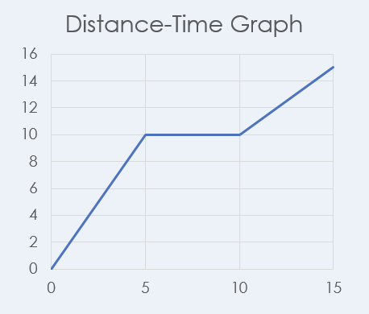
Velocity-Time graphs can be used as well as distance-time graphs to describe the motion of an object. Time is recorded on the $x$ axis and velocity is recorded on the $y$ axis.
Constant velocity
Constant velocity
Decreasing velocity (constant deceleration)
Increasing velocity (constant acceleration)

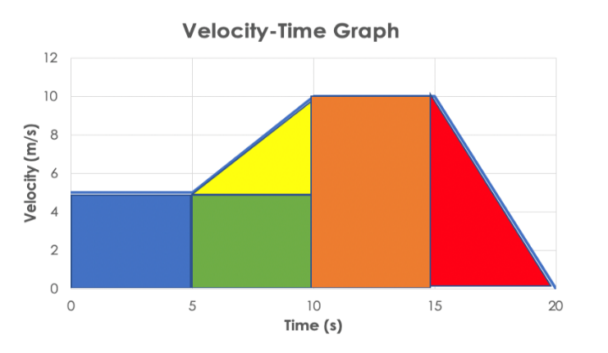
Features of a velocity-time graph:
- A horizontal line shows that the object has a constant velocity
- A straight line with a positive gradient shows the object is accelerating (the velocity is increasing)
- A straight line with a negative gradient shows the object is decelerating (the velocity is decreasing)
- If the velocity is 0 m/s the object is stationary
- The distance travelled can be determined by calculating the area under the graph
- This may involve splitting the area under the graph into rectangles and triangles (see below)
- State the definitions of:
Activities
and Practice
- Velocity
_____________________________________________________________________
_____________________________________________________________________
_____________________________________________________________________
- Acceleration
_____________________________________________________________________
_____________________________________________________________________
_____________________________________________________________________
- Complete the table to describe the features of distance-time graphs and velocity-time graphs.

 | Displacement-Time Graph | Velocity-Time Graph
Horizontal line
Positive gradient
Negative gradient
What can be calculated from the gradient?

3. Describe how to calculate the distance travelled by an object from a velocity-time graph.
________________________________________________________________________
________________________________________________________________________
________________________________________________________________________
- Use the following velocity-time graph to answer the questions.

- Describe the motion of this object between:
  - 0 and 5 seconds

  - 5 and 10 seconds

  - 10 and 15 seconds

  - 15 and 20 seconds
- Calculate the distance travelled by this object during the 20 seconds.

- Use the following velocity-time graph to answer the questions.

- Describe the motion of this object between:
  - 0 and 5 seconds

  - 5 and 10 seconds

  - 10 and 15 seconds

  - 15 and 20 seconds

  - 20 and 25 seconds

  - 25 and 30 seconds

- Calculate the distance travelled by this object during the 20 seconds.

- Use the information to draw a velocity-time graph to describe the motion of the following journey:

A sprinter lines up at the start line. After the starting gun he accelerates to 10 m/s within 2 seconds. He continues running at 10 m/s for another 8 seconds until he reaches the finish line. After he crosses the finish line he slows down to a jog
(5 m/s) within 4 seconds. He then slows down to a stop which takes another second.

Calculate the total distance travelled by the sprinter using your velocity-time graph.
1. What does a horizontal line represent on a velocity-time graph?
Exit Ticket

A. Constant velocity
B. A stationary object
C. Increasing velocity
2. What can be calculated from the area under a velocity-time graph?
A. Distance travelled
B. Average velocity
C. Total time taken
3. What does a negative gradient represent on a velocity-time graph?
A. An object stopping
B. An object returning to its original position
C. An object slowing down
For question 1, read the guidance below and carry out the ‘fix-it’ task which has been set for you.
If you answered A
Velocity-time graphs are used to show the velocity of an object during a journey. A horizontal line on a velocity-time graph shows that the velocity of the object is not changing, meaning it is travelling at a constant velocity.
Compare the meaning of a horizontal line on velocity-time graph with a horizontal line on a distance-time graph.

If you answered B
Velocity-time graphs are used to show the velocity of an object during a journey. A horizontal line on a distance-time graph represents a stationary object as no distance is covered in a given time. However a horizontal line on a velocity-time graph shows that the velocity of the object is not changing, meaning it is travelling at a constant velocity.
Describe the differences between a velocity-time graph and a distance-time graph.

If you answered C
Velocity-time graphs are used to show the velocity of an object during a journey. An increasing velocity (acceleration) would be represented with a positive gradient (slope). A horizontal line on a velocity-time graph shows that the velocity of the object is not changing, meaning it is travelling at a constant velocity.
Compare the meaning of a positive gradient on a distance-time graph with a positive gradient on a velocity-time graph.
Do Now:
New Learning
Velocity-Time Graphs 2
    - What values are on the x and y axes of a velocity-time graph?
________________________________________________________________________
- What is represented by a horizontal line on a velocity-time graph?​
________________________________________________________________________
- What does a negative gradient represent on a velocity-time graph?​
________________________________________________________________________
- Describe how to calculate the distance travelled using a velocity-time graph.
________________________________________________________________________
- State the equation that links speed, distance and time.
________________________________________________________________________

Foundation: State the definition of acceleration.
________________________________________________________________________

Stretch: Describe the motion represented by the below velocity-time graph.
________________________________________________________________________
________________________________________________________________________
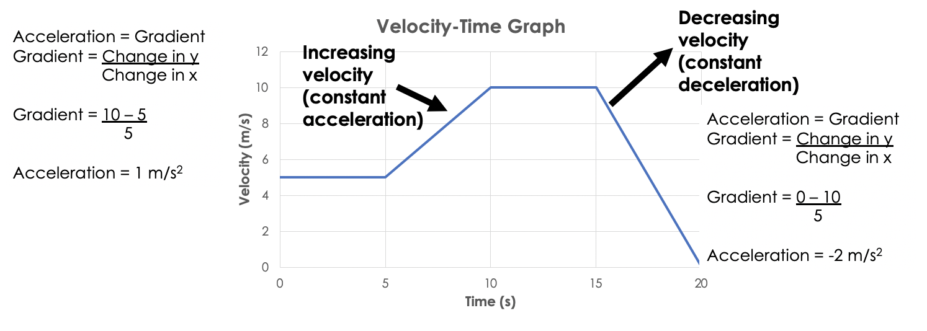
A negative velocity shows that the object is travelling in the opposite direction:
The acceleration of an object can be calculated using the gradient (slope) of a velocity-time graph. This uses the change in velocity divided by the change in time.

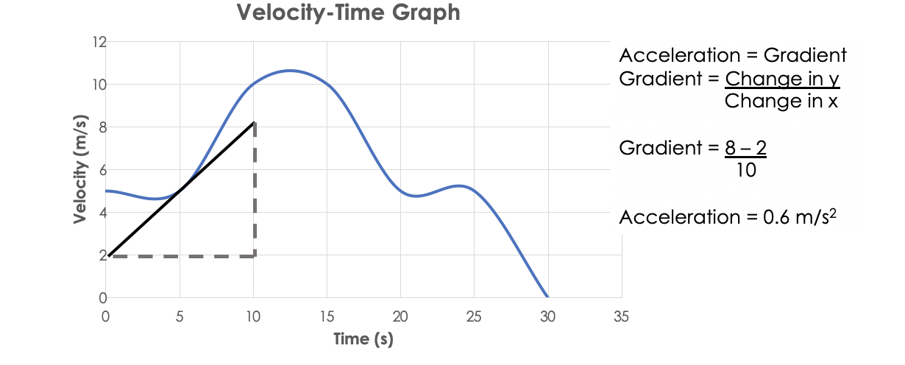
A curved line on a velocity-time graph indicates that the acceleration is changing. The acceleration at a specific point in time can be calculated by drawing a tangent to the curve and calculating the gradient of the tangent.

- Use the following velocity-time graph to answer the questions.
Activities
and Practice

- Describe the motion of this object.
____________________________________________________________________
____________________________________________________________________
____________________________________________________________________
____________________________________________________________________
____________________________________________________________________
- Calculate the total distance travelled by this object.

- Calculate any values for acceleration for this graph.

- Use the following velocity-time graph to answer the questions.
- Describe the motion of this object.
____________________________________________________________________
____________________________________________________________________
____________________________________________________________________
____________________________________________________________________
____________________________________________________________________

- Calculate the distance travelled by this object in the first 40 seconds.

- Calculate:

- The acceleration between 0 and 10 seconds

- The acceleration between 20 and 30 seconds

- Describe how you could calculate the acceleration of this object after 45 seconds.

- Use your method from the previous question to calculate the acceleration of this object after 45 seconds

- Use the following velocity-time graph to answer the questions.
- Describe the motion of this object.
____________________________________________________________________
____________________________________________________________________
____________________________________________________________________
____________________________________________________________________
____________________________________________________________________
- Calculate the total distance travelled by this object.

- Calculate the final displacement of the object.

- Calculate:

  - The acceleration between 5 and 10 seconds

  - The acceleration between 15 and 20 seconds

  - The acceleration between 20 and 25 seconds

  - The acceleration between 30 and 35 seconds

1. What can be calculated from the gradient of a velocity-time graph?
Exit Ticket
A. Distance travelled
B. Acceleration
C. Velocity

2. What does a curved line represent on a velocity-time graph?
A. Constant velocity
B. Constant acceleration
C. Changing acceleration
3. Which of these would not have a negative value for acceleration?
A. An object speeding up in the opposite direction
B. An object slowing down
C. A stationary object
For question 1, read the guidance below and carry out the ‘fix-it’ task which has been set for you.
If you answered A
The distance travelled can be calculated from the area under the graph on a velocity-time graph. The gradient of a velocity-time graph can be used to calculate the acceleration of an object as it shows the rate of change in the object’s velocity.
Compare and contrast the features of distance-time graphs and velocity-time graphs.
If you answered B
The gradient of a velocity-time graph represents the change in velocity over time of an object, meaning that it can be used to calculate the acceleration.
Suggest why the area under the graph on a velocity-time graph can be used to calculate the distance that the object has travelled.
If you answered C
Velocity is how fast an object travels in a given direction and is shown on the y axis of a velocity-time graph. The gradient of a velocity-time graph represents the change in velocity of an object in a given time, which is its acceleration.
Describe what is represented by a positive gradient on a velocity-time graph and a positive gradient on a distance-time graph.
Do Now:
New Learning
Acceleration Problems
- State the equation to calculate acceleration.
________________________________________________________________________
- State the SI units for acceleration.
________________________________________________________________________
- Explain why acceleration is a vector quantity.
________________________________________________________________________
- Compare the meaning of a horizontal line on a distance-time graph and a velocity-time graph.
________________________________________________________________________
- Name the quantity that can be determined from the gradient of a velocity-time graph.
________________________________________________________________________

Foundation: What does a horizontal line on a velocity-time graph represent?
________________________________________________________________________

Stretch: Compare the features of velocity-time graphs and distance-time graphs.
________________________________________________________________________
________________________________________________________________________
Acceleration can occur vertically as well as horizontally. Newton’s First Law states that an objects motion will not change unless acted upon by an unbalanced force. This also applies to objects travelling up and down, such as rockets taking off and landing. The same rules apply with velocity-time graphs when describing vertical motion.
A group of students want to use a model rocket to help them explain the Physics involved in launching a rocket, which is an area that many technology companies are interested in and investing in.
Activities
and Practice
The students wanted to know the perfect amount of fuel to put into the rocket so tested it with 100g of fuel as a preliminary investigation. They launched the rocket and recorded its velocity before, during and after its launch and then plotted their recordings in the velocity time graph below.
- On the graph mark:
- The point where the rocket ran out of fuel
- The highest point the rocket reached
- The point where the rocket hit the ground

- Describe the motion of the rocket over the 10 seconds.

- Explain the velocity changes in terms of the forces acting on the rocket
________________________________________________________________________
________________________________________________________________________
________________________________________________________________________
________________________________________________________________________
________________________________________________________________________
________________________________________________________________________
________________________________________________________________________
________________________________________________________________________
________________________________________________________________________
________________________________________________________________________
________________________________________________________________________
________________________________________________________________________
________________________________________________________________________
________________________________________________________________________
________________________________________________________________________
________________________________________________________________________
________________________________________________________________________
________________________________________________________________________
________________________________________________________________________
________________________________________________________________________
________________________________________________________________________
________________________________________________________________________
________________________________________________________________________
________________________________________________________________________

1. Which scenario would have a non-zero resultant force?
Exit Ticket
A. An object travelling at constant velocity
B. A stationary object
C. An object decelerating

2. At what point would a rocket have a velocity of 0 m/s?
A. Just before it hits the ground
B. At its highest point
C. Just after it takes off

3. Which would show an object decelerating on a velocity-time graph?
A. A negative gradient
B. A positive gradient
C. A horizontal line at 0 on the y axis
For question 1, read the guidance below and carry out the ‘fix-it’ task which has been set for you.
If you answered A
Newton’s First Law states that an object’s motion will not change unless acted upon by an unbalanced force. An unbalanced force is a non-zero resultant force. An object travelling at constant velocity has a constant motion, meaning that its motion is not changing and therefore is being acted upon by balanced forces.
Describe the effects of balanced and unbalanced forces on stationary objects and objects that are already in motion.
If you answered B
Newton’s First Law states that an object’s motion will not change unless acted upon by an unbalanced force. An unbalanced force is a non-zero resultant force. A stationary object has a constant motion (of 0), meaning that its motion is not changing and therefore is being acted upon by balanced forces.
Describe the effects of balanced and unbalanced forces on stationary objects and objects that are already in motion.
If you answered C
Newton’s First Law states that an object’s motion will not change unless acted upon by an unbalanced force. An unbalanced force is a non-zero resultant force. An object decelerating has a decreasing velocity, which means that its motion is changing. This shows that it must be being acted upon by a non-zero resultant force.
Explain how we can tell the direction of the resultant force acting on an object based on if it is accelerating or decelerating.
Daisy Abbott
Scientist in the Spotlight

Science and Technology Artist
Daisy Abbott is a British artist who combines science and technology with traditional art and design forms at the Glasgow School of Art and Design. She studied art and design, science and maths at A-level, going on to do a bachelor’s degree in theatre, film and television, followed by a master’s in information technology and humanities. Her work involves the use of technology in designing games, visualising art forms and education. Turning abstract scientific concepts into visual art forms and representations is very useful for many areas of science. In physics, it is particularly helpful to represent forces, otherwise we would not be able to visualise them. This allows us to be able to use them in calculations for important applications, including designing the structures of cars, aeroplanes and rockets.
Daisy describes a scientist as someone who is creative, rigorous and willing to be wrong sometimes. A typical day for Daisy involves writing up bids for funding for various research projects that combine art and technology. An amazing application of her work involved creating a huge, fully 3D architectural model. She also enjoys going to art festivals and workshops to talk about the work she does with her students and learn about other projects. One of her recent jobs was designing a game about people working together to change climate policy in their university that is played across different media platforms.
The freedom to choose what she works on is one of the best things about Daisy’s job. She believes that everyone can do maths and learn computer programming, contrary to the belief that STEM subjects are not for everyone or are intrinsically harder to understand. She is passionate about education and believes that a student’s interest in STEM subjects depends on the presentation of it. She considers that it is very useful to have the skills that one can learn from studying STEM subjects, which can even be applicable in daily life, like making outdoor treasure hunts for kids.
Daisy’s advice for future students who are interested in studying science is to not just focus on the subject, but to also pay attention to the method and way of thinking when doing science. So she encourages people not to be afraid of science but embrace it and think of it as a useful tool for life.
Activity
Use the scientist’s profile to answer the following questions:
- What is the scientist’s job?
________________________________________________________________________
________________________________________________________________________
________________________________________________________________________
- Briefly describe what the scientist does in a typical day.
________________________________________________________________________
________________________________________________________________________
________________________________________________________________________
- What skills do they need for this job?
________________________________________________________________________
________________________________________________________________________
________________________________________________________________________
- What do you think is the most interesting part of their job?
________________________________________________________________________
________________________________________________________________________
________________________________________________________________________
- Describe how this job links with the science you have learned in this unit.
________________________________________________________________________
________________________________________________________________________
________________________________________________________________________
- State the definition of any words in bold.
________________________________________________________________________
________________________________________________________________________
________________________________________________________________________

